Come and study in the European Union - enrich your education and prepare yourself for the FUTURE.  The INFINITY project is a Higher Education experience - funded by the European Union - for the exchange of knowledge in the areas of:  01 Agriculture Sciences  02 Architecture, Urban/Regional Planning  04 Business Studies, Management Science  06 Engineering, Technology  07 Geography, Geology  13 Natural Sciences  14 Social Sciences.  Participate and earn your scholarship to come learn at the universities of the Czech Republic, Estonia, Portugal, and Slovenia.  Mobility types: Monthly allowances  - Undergraduate; 1000€  - Master; 1000€  - Doctorate; 1500€  - Post-doc; 1800€  - Staff 2500€  In addition, your scholarship also includes travel costs, tuition and health insurance.  If you speak English (Czech, or Estonian or Portuguese, or Slovene), and are interested to be part, of the INFINITY Project, please apply from the 20th of November to the 31th of January of 2015 using http://infinity.fa.ulisboa.pt  If you have any questions, please contact us:  infinity@fa.utl.pt  https://www.facebook.com/Infinity.fpt | Come and study in the European Union - enrich your education and prepare yourself for the FUTURE.  The INFINITY project is a Higher Education experience - funded by the European Union - for the exchange of knowledge in the areas of:  01 Agriculture Sciences  02 Architecture, Urban/Regional Planning  04 Business Studies, Management Science  06 Engineering, Technology  07 Geography, Geology  13 Natural Sciences  14 Social Sciences.  Participate and earn your scholarship to come learn at the universities of the Czech Republic, Estonia, Portugal, and Slovenia.  Mobility types: Monthly allowances  - Undergraduate; 1000€  - Master; 1000€  - Doctorate; 1500€  - Post-doc; 1800€  - Staff 2500€  In addition, your scholarship also includes travel costs, tuition and health insurance.  If you speak English (Czech, or Estonian or Portuguese, or Slovene), and are interested to be part, of the INFINITY Project, please apply from the 20th of November to the 31th of January of 2015 using http://infinity.fa.ulisboa.pt  If you have any questions, please contact us:  infinity@fa.utl.pt  https://www.facebook.com/Infinity.fpt | Come and study in the European Union - enrich your education and prepare yourself for the FUTURE.  The INFINITY project is a Higher Education experience - funded by the European Union - for the exchange of knowledge in the areas of:  01 Agriculture Sciences  02 Architecture, Urban/Regional Planning  04 Business Studies, Management Science  06 Engineering, Technology  07 Geography, Geology  13 Natural Sciences  14 Social Sciences.  Participate and earn your scholarship to come learn at the universities of the Czech Republic, Estonia, Portugal, and Slovenia.  Mobility types: Monthly allowances  - Undergraduate; 1000€  - Master; 1000€  - Doctorate; 1500€  - Post-doc; 1800€  - Staff 2500€  In addition, your scholarship also includes travel costs, tuition and health insurance.  If you speak English (Czech, or Estonian or Portuguese, or Slovene), and are interested to be part, of the INFINITY Project, please apply from the 20th of November to the 31th of January of 2015 using http://infinity.fa.ulisboa.pt  If you have any questions, please contact us:  infinity@fa.utl.pt  https://www.facebook.com/Infinity.fpt

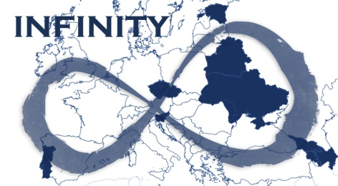  The INFINITY project intends to build and strengthen an INternational Fellowship IN transdisciplinarITY - its main theme is “Architecture and Urban Agriculture”.  The INFINITY Project    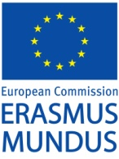  funded by Erasmus Mundus Programme of the European Union | The INFINITY project intends to build and strengthen an INternational Fellowship IN transdisciplinarITY - its main theme is “Architecture and Urban Agriculture”.  The INFINITY Project  funded by Erasmus Mundus Programme of the European Union | The INFINITY project intends to build and strengthen an INternational Fellowship IN transdisciplinarITY - its main theme is “Architecture and Urban Agriculture”.  The INFINITY Project  funded by Erasmus Mundus Programme of the European Union

